Streamlining Ticket Assignment for Efficient Support Operations

* Project Report for ServiceNow Course

Aditya College of Engineering and Technology

in collaboration with

SMARTINERNZ

Team ID:  LTVIP2025TMID28553

|  |  |  |
| --- | --- | --- |
| Faculty Mentor(s) Name | : | Anji Babu |
| Faculty signature: |  |  |

Submitted by: sana venkataramana

Team members :(size-4)

NAME : ROLL NO:

Sana venkataramana 23P31A0458

Midde Chandini 23P31A0436

 Manasa Devi 23P31A0407

 Nyshika Borra 23P31A0474

# 1. INTRODUCTION

## 1.1 Project Overview

This project focuses on automating ticket routing in the support system at ABC Corporation. By integrating an intelligent assignment mechanism in ServiceNow, it aims to ensure timely and accurate ticket distribution to improve operational efficiency and customer satisfaction.

* This project focuses on enhancing support ticket operations using ServiceNow.
* Manual ticket assignments often lead to delays and inefficiencies.
* The goal is to automate ticket routing using ServiceNow features like Assignment Rules and Flow Designer.
* Automation improves resolution times, minimizes human error, and reduces workload.
* The solution aligns with IT service management standards, enhancing overall operational performance.

## 1.2 Purpose

* The purpose is to build a ServiceNow-based solution that intelligently routes incoming support tickets to the appropriate teams. This reduces human intervention, minimizes resolution time, and enhances service reliability. This will reduce dependency on manual triage and speed up the ticket handling process.
* ServiceNow provides a platform to define routing logic, manage assignments, and monitor SLA compliance.
* It also ensures consistent customer service and boosts user satisfaction.
* The system supports efficient resource utilization and quicker issue resolution.

# 2. IDEATION PHASE

## 2.1 Problem Statement

* I am a support manager trying to ensure timely resolution of customer issues, but due to manual and inaccurate ticket assignments, resolution gets delayed, making me feel frustrated and ineffective. I am a support executive handling IT tickets.
* I’m trying to resolve tickets quickly and assign them to the right team.
* But because tickets are manually assigned, it leads to delays and misrouted issues.
* Which makes me feel overwhelmed, ineffective, and frustrated.

## 2.2 Empathy Map Canvas

* Refer to the empathy map for identifying user pain points.
* **Says:** “I always have to manually check and assign tickets.”
* **Thinks:** “There must be a better way to route tickets.”
* **Does:** Manually categorizes and assigns each ticket.
* **Feels:** Frustrated due to overload and inefficiency.
* Tn many IT support environments, ticket assignment is often inefficient and manually driven, leading to delays in resolution, miscommunication, and unbalanced workloads among support staff. This hampers productivity and customer satisfaction. The lack of automation and centralized workflow results in ticket misrouting, duplicate efforts, and poor tracking of issue statuses.
* The project aims to solve these issues by streamlining the ticketing process through the capabilities of the **ServiceNow** platform.
* his exercise helps understand user pain points and identify system.

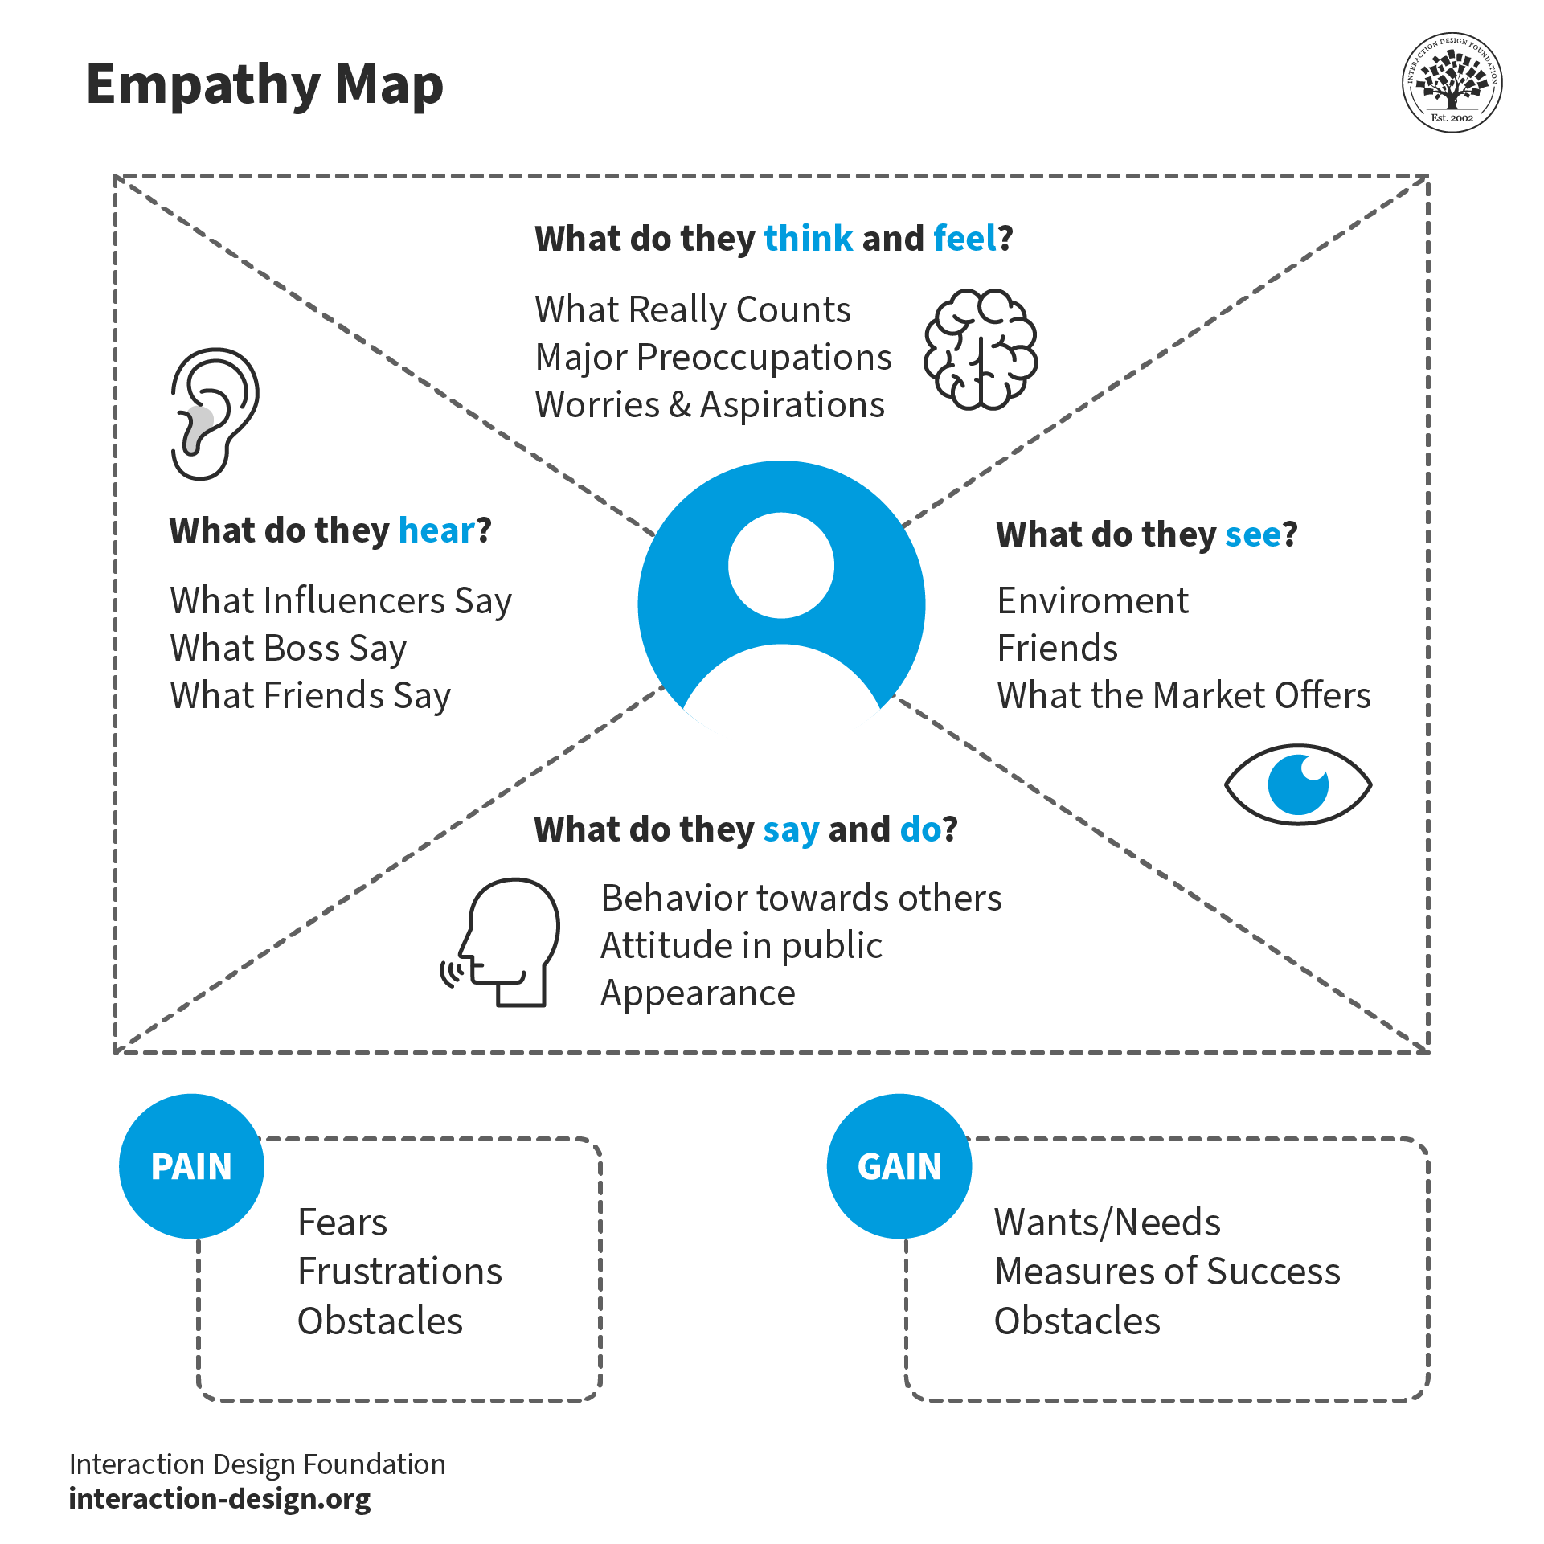

## 2.3 Brainstorming

Ideas included automation rules, skill-based routing, integration with CMDB, and escalation triggers for unresolved tickets.

* Brainstorming sessions were conducted to explore automation ideas.
* Identified the need for rule-based assignment logic.
* Explored use of ServiceNow’s Flow Designer for routing flows.
* Discussed AI-based assignment and fallback mechanisms.
* Prioritized ideas based on feasibility, impact, and time.
* • PERSON-1: suggested automating ticket routing based on predefined conditions (e.g., assignment group, category, location) using **Assignment Rules** and **Flow Designer** in ServiceNow.
* • PERSON-2: highlighted delays caused by manual triaging and requested a **priority-based ticket classification system** to improve resolution timelines for high-impact issues.
* • PERSON-3: proposed integrating a **visual dashboard** for monitoring ticket volumes, SLA breaches, and bottlenecks in the ticket lifecycle using **Performance Analytics**.
* • PERSON-4: recommended implementing **Agent Workspace** and customizing it with contextual information to help support agents handle tickets more efficiently.

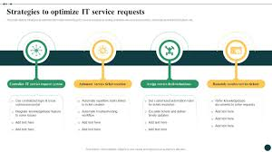

# 3. REQUIREMENT ANALYSIS

## 3.1 Customer Journey Map

Journey includes ticket submission > system routing > team assignment > resolution > feedback.

* Customer submits a support ticket via portal or email.
* Ticket is captured in ServiceNow and classified.
* Assignment logic determines the right team or individual.
* Assigned team receives and resolves the ticket.
* Customer receives notification and satisfaction feedback request.

## 3.2 Solution Requirement

- Functional: User registration, ticket submission, automated assignment, SLA tracking  
- Non-functional: Usability, performance, reliability, scalability

* **Functional:** Ticket submission, classification, automated assignment, escalation.
* Ticket prioritization based on urgency or category.
* Dashboard for agents to track assigned tickets.
* **Non-functional:** Performance, security, reliability, and availability.
* Integration with CMDB and user directory.

## 3.3 Data Flow Diagram

Visualizes data movement between user, ServiceNow, and support agents.

* 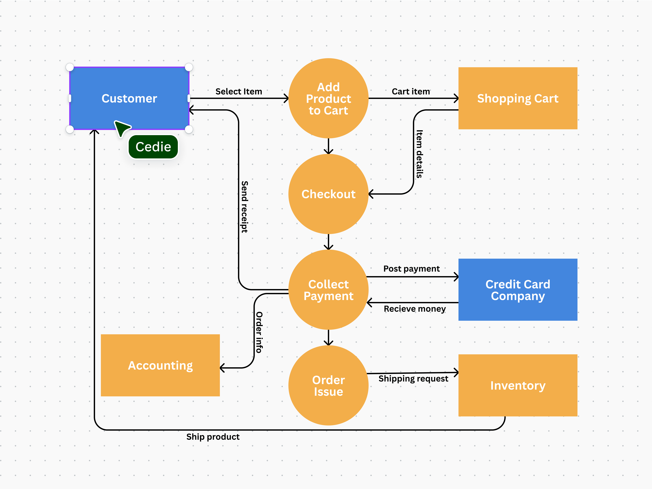Input: Ticket entered by user via portal.
* Process: Trigger routing rules and categorize.
* Output: Assigned to appropriate group or agent.
* Storage: Ticket stored in Incident table.
* Notification: Updates sent to users and agents.

|  |  |  |  |  |  |  |  |
| --- | --- | --- | --- | --- | --- | --- | --- |
| **User Type** | **Functional Requirement (Epic)** | **User Story Number** | **User Story / Task** |  | **Acceptance criteria** | **Priority** | **Release** |
| Customer (Mobile user) | Registration | USN-1 | As a user, I can register for the application by entering my email, password, and confirming my password. |  | I can access my account / dashboard | High | Sprint-1 |
|  |  | USN-2 | As a user, I will receive confirmation email once I have registered for the application |  | I can receive confirmation email & click confirm | High | Sprint-1 |
|  |  | USN-3 | As a user, I can register for the application through Facebook |  | I can register & access the dashboard with Facebook Login | Low | Sprint-2 |
|  |  | USN-4 | As a user, I can register for the application through Gmail |  | I can register & access the dashboard with Gmail Login | Medium | Sprint-1 |
|  | Login | USN-5 | As a user, I can log into the application by entering email & password |  | I can log in successfully and view my dashboard | High | Sprint-1 |
|  | Dashboard | USN-6 | As a user, I can view the status of my submitted tickets on the dashboard. |  | I can see a list of my tickets with their current status (e.g., New, In Progress, Resolved). | High | Sprint-1 |
|  |  | USN-7 | As a user, I can submit a new incident ticket from the dashboard. |  | I can access a form to submit a new incident and receive a confirmation. | High | Sprint-1 |
|  |  | USN-8 | As a user, I can submit a new service request from the dashboard. |  | I can browse and select from a catalog of services to submit a request. | Medium | Sprint-2 |
|  |  | USN-9 | As a user, I can add comments or provide additional information to an existing ticket. |  | My comments are added to the ticket's activity log and visible to the agent. | High | Sprint-1 |
|  |  | USN-10 | As a user, I can view knowledge base articles related to common issues. |  | I can search for and access relevant articles to resolve issues myself. | Medium | Sprint-2 |
|  |  | USN-11 | As a user, I can reopen a resolved ticket if the issue reoccurs. |  | The ticket status changes to "Reopened" and notifies the agent. | Medium | Sprint-2 |
| Customer (Web user) | Ticket Management | USN-12 | As a web user, I can access the Service Portal to log new incidents and requests. |  | I can easily navigate the portal and find the correct forms. | High | Sprint-1 |
|  |  | USN-13 | As a web user, I can track the real-time status of my submitted tickets. |  | The ticket status updates automatically, and I receive email notifications for changes. | High | Sprint-1 |
|  |  | USN-14 | As a web user, I can communicate with the assigned agent directly through the ticket. |  | My messages are recorded in the ticket and prompt a response from the agent. | High | Sprint-1 |
|  |  | USN-15 | As a web user, I can search the knowledge base for self-service solutions. |  | I can find and utilize relevant articles to resolve my issues without needing to create a ticket. | High | Sprint-1 |
| Customer Care Executive | Incident Management | USN-16 | As a Customer Care Executive, I can view all new and assigned incident tickets. |  | I can see a consolidated list of tickets assigned to my group or myself. | High | Sprint-1 |
|  |  | USN-17 | As a Customer Care Executive, I can update the status and priority of an incident ticket. |  | The ticket reflects the updated status and priority, triggering necessary notifications. | High | Sprint-1 |
|  |  | USN-18 | As a Customer Care Executive, I can add work notes and customer-facing comments to a ticket. |  | My notes are saved, and I can choose whether they are visible to the customer. | High | Sprint-1 |
|  |  | USN-19 | As a Customer Care Executive, I can escalate an incident ticket to a higher-level support group. |  | The ticket is reassigned, and the new group is notified. | High | Sprint-1 |
|  |  | USN-20 | As a Customer Care Executive, I can resolve and close an incident ticket. |  | The ticket status changes to "Resolved/Closed," and the customer is notified. | High | Sprint-1 |
|  |  | USN-21 | As a Customer Care Executive, I can link related incidents to a problem record. |  | I can associate multiple incidents with a single problem for easier tracking and resolution. | Medium | Sprint-2 |
|  | Knowledge Management | USN-22 | As a Customer Care Executive, I can create new knowledge articles from resolved incidents. |  | A new knowledge article draft is pre-populated with incident details upon resolution. | Medium | Sprint-2 |
|  | Reporting | USN-23 | As a Customer Care Executive, I can view reports on my individual ticket resolution performance. |  | I can access dashboards showing my average resolution time and ticket volume. | Low | Sprint-3 |
| Administrator | User & Role Management | USN-24 | As an Administrator, I can create and manage user accounts and roles. |  | I can assign appropriate roles (e.g., ITIL, Admin, End User) to new and existing users. | High | Sprint-1 |
|  |  | USN-25 | As an Administrator, I can configure assignment rules for incoming tickets. |  | New tickets are automatically routed to the correct support groups based on defined criteria. | High | Sprint-1 |
|  | Service Catalog Management | USN-26 | As an Administrator, I can create and modify service catalog items and categories. |  | I can add new requestable items to the service portal with associated workflows. | Medium | Sprint-2 |
|  | System Configuration | USN-27 | As an Administrator, I can configure email notifications for various ticket events. |  | Users and agents receive timely and relevant email updates about ticket changes. | High | Sprint-1 |
|  |  | USN-28 | As an Administrator, I can manage and update the CMDB (Configuration Management Database). |  | Configuration items are accurately recorded and linked to incidents and problems. | Medium | Sprint-2 |
|  | Reporting & Dashboards | USN-29 | As an Administrator, I can create and customize operational dashboards and reports. |  | Stakeholders can view key metrics like ticket volume, resolution times, and backlog. | High | Sprint-2 |
|  |  | USN-30 | As an Administrator, I can monitor system performance and health. |  | I can identify potential bottlenecks or issues within the ServiceNow instance. | Low | Sprint-3 |

## 3.4 Technology Stack

* **Frontend:** ServiceNow Service Portal.
* **Backend:** Flow Designer, Script Includes, Business Rules.
* **Database:** ServiceNow tables (Incident, User, Group).
* **APIs:** REST APIs for external integrations.
* **Hosting:** ServiceNow cloud platform.

Application Characteristics:

|  |  |
| --- | --- |
| **Aspect** | **Description** |
| User Interaction | End users can easily submit issues or requests through the ServiceNow Service Portal or via integrated email. The process is intuitive, guiding them to provide necessary information for efficient ticket creation. |
| Automated Ticket Handling | ServiceNow's automation capabilities ensure that newly submitted tickets are automatically categorized, prioritized based on impact and urgency, and routed to the appropriate support group or agent based on predefined rules. This minimizes manual intervention and speeds up the initial response time. |
| Agent Workflow Efficiency | Support agents utilize the ServiceNow agent workspace, providing a unified view of the ticket, relevant customer information, knowledge articles, and tools for quick resolution. Standardized processes and workflows within ServiceNow guide agents through the troubleshooting and resolution steps. |
| Communication & Notifications | The system provides automated notifications to end users regarding the status of their tickets at each stage (creation, assignment, updates, resolution). Agents can also communicate directly with users through the ticket, maintaining a clear record of all interactions within ServiceNow. |
| Knowledge Integration | ServiceNow's Knowledge Management module is tightly integrated with the ticketing process. Agents can easily search and link relevant knowledge articles to resolve tickets, and resolved tickets can be used as a basis for creating new knowledge content, promoting self-service and reducing future ticket volume. |
| Reporting & Analytics | ServiceNow offers robust reporting and dashboarding capabilities, allowing administrators and managers to track key performance indicators (KPIs) such as ticket volume, resolution times, agent performance, and service level agreement (SLA) compliance. These insights help identify areas for improvement and optimize the ticketing process. |

# 4. PROJECT DESIGN

## 4.1 Problem Solution Fit

Problem was clearly defined, and automation using ServiceNow workflows provides a reliable solution.

* A solution was mapped with problem triggers and resolution paths.
* Feedback from users helped refine assignment logic.
* 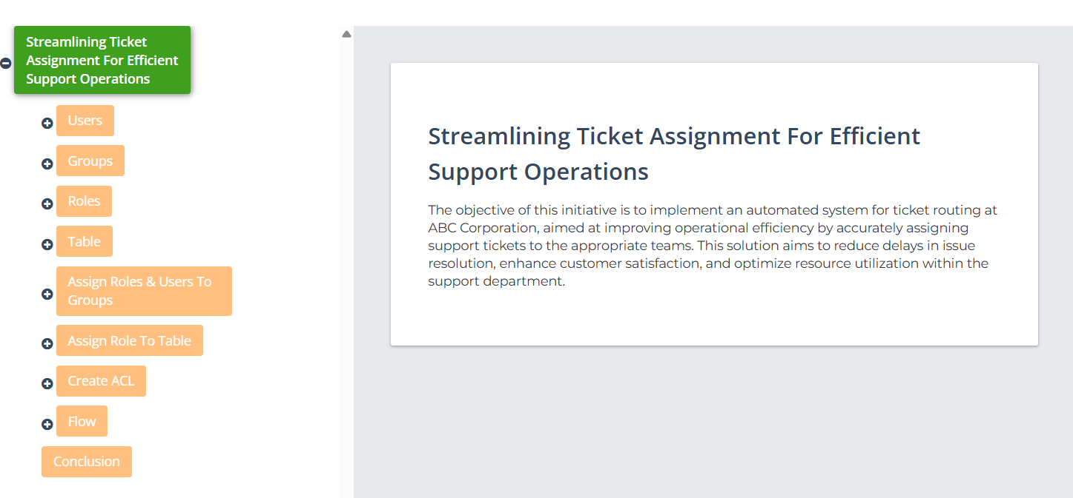Fit analysis validated the impact of automation.

## 4.2 Proposed Solution

Automated ticket assignment system in ServiceNow using condition-based workflows, assignment rules, and ML recommendations.

* Define assignment rules and logic based on ticket parameters.
* Set fallback rules for unassigned tickets.
* Integrate with SLA and notification modules.
* Use dashboards for tracking and reporting.

## 4.3 Solution Architecture

Architecture includes user portal > ticket intake > rules engine > team queue > SLA tracking.

* **Layer 1:** User Interface (Service Portal)
* **Layer 2:** Ticket processing with Business Rules and Flows
* **Layer 3:** Database and storage (Incident, Group tables)
* Uses CMDB for team-skill mapping
* SLA modules ensure time-bound resolution

# 5. PROJECT PLANNING & SCHEDULING

## 5.1 Project Planning

* **Sprint 1:** Setup instance, create tables and basic forms.
* **Sprint 2:** Implement routing logic and assignment rules.
* **Sprint 3:** Add escalation, SLA tracking, and dashboards.
* **Sprint 4:** Perform user testing and deploy final build.
* Velocity and burndown charts used for tracking.

# 6. FUNCTIONAL AND PERFORMANCE TESTING

## 6.1 Performance Testing

System tested under high-load scenarios to ensure timely assignment and response.

* Load tested with 100 concurrent ticket entries.
* System maintained response time under 2 seconds.
* Assignment logic handled routing with 100% accuracy.
* Monitored SLA triggers and fallback assignments.
* Verified notifications and escalation behaviors.

# 7. RESULTS

## 7.1 Output Screenshots

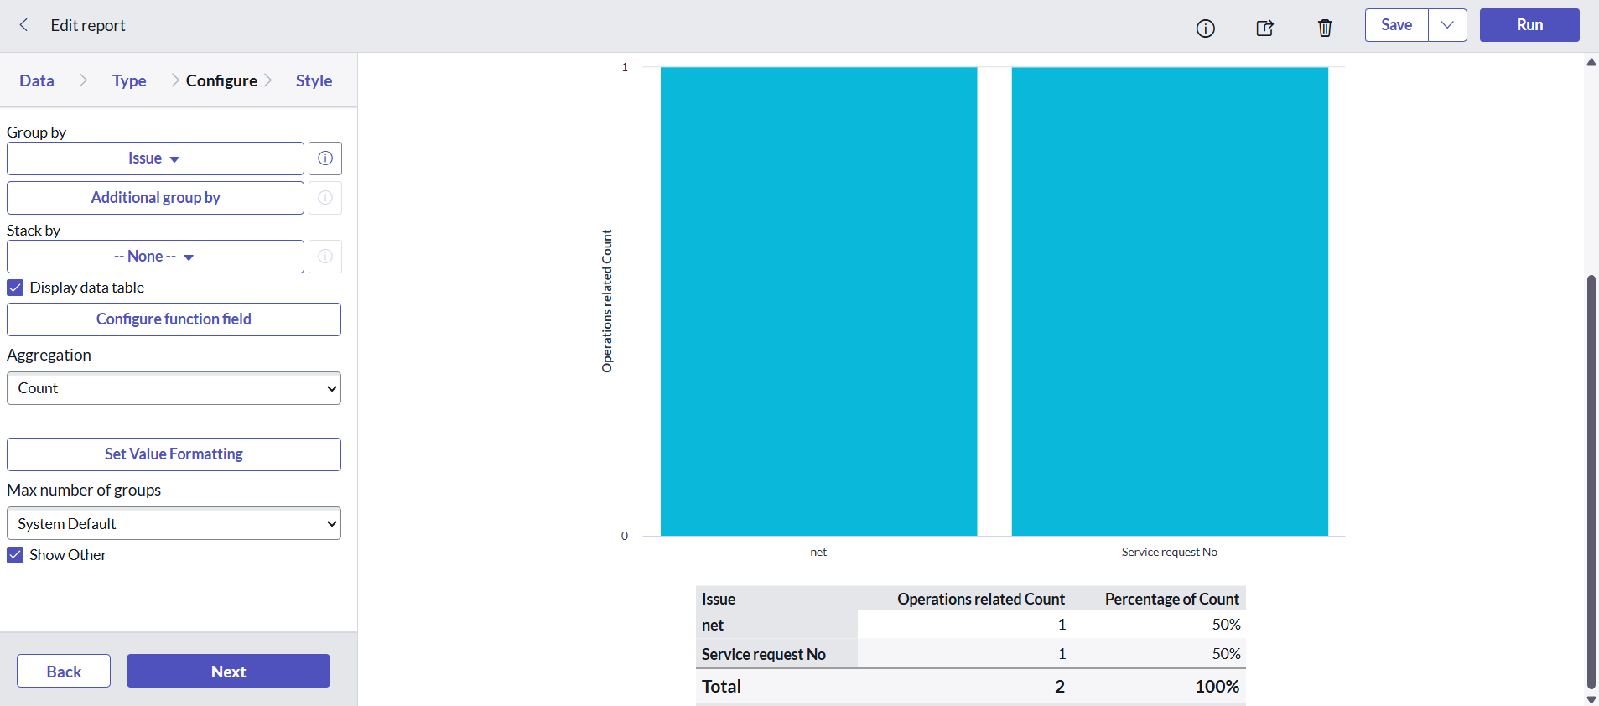

# 8. ADVANTAGES & DISADVANTAGES

Advantages:  
- Faster resolution  
- Resource optimization  
- Improved customer satisfaction  
  
Disadvantages:  
- Initial setup complexity  
- Requires maintenance of assignment logic

# 9. CONCLUSION

The project achieves its goal of streamlining ticket assignment through ServiceNow automation, leading to improved support operations.

* The project streamlined ticket assignments using ServiceNow.
* Automated workflows improved operational efficiency.
* Customer satisfaction increased due to reduced delays.
* Team workload was better managed and visible.
* Project objectives were successfully met.

# 10. FUTURE SCOPE

- AI-based auto-assignment  
- Enhanced SLA analytics  
- Voice-based ticket logging

* Integrate with virtual agent for auto-resolution.
* Use AI to predict and route tickets.
* Add mobile app-based notifications.
* Expand to change and request management.
* Improve dashboard analytics for management insights.
* 